ICP 3 Report

Madhuri Gopisetty

700768689

a. Using NumPy create random vector of size 15 having only Integers in the range 1-20. 1. Reshape the array to 3 by 5 2. Print array shape. 3. Replace the max in each row by 0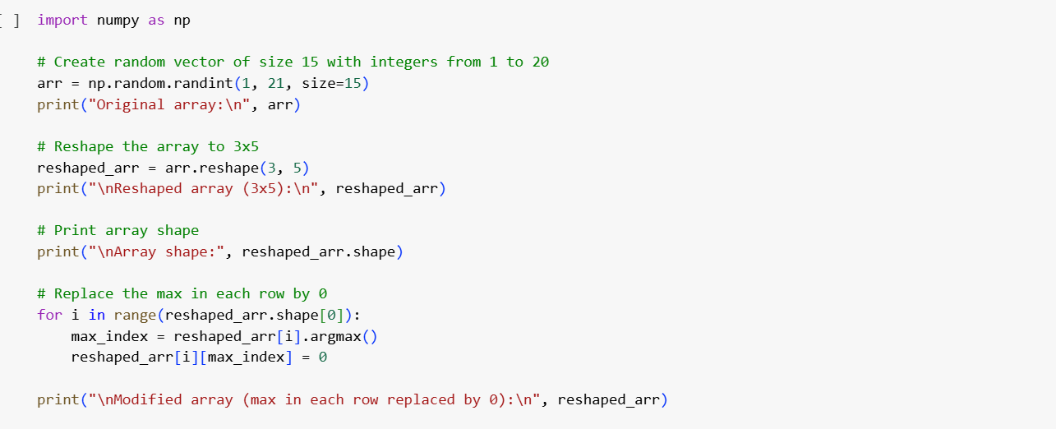

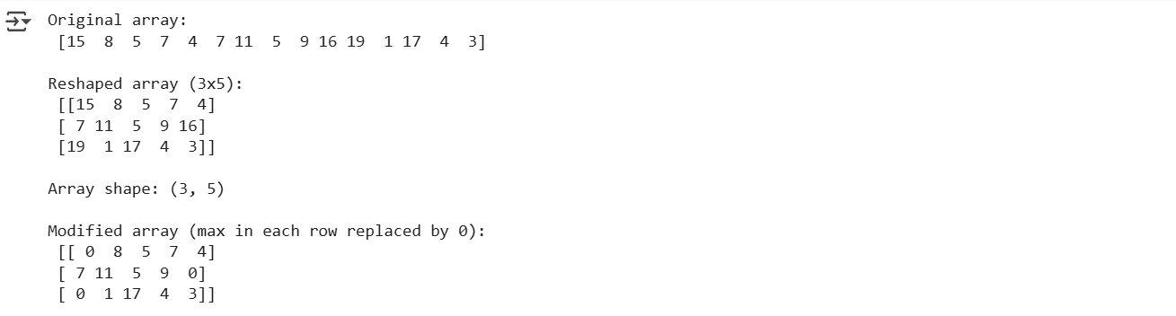

b. Create a 2-dimensional array of size 4 x 3 (composed of 4-byte integer elements), also print the shape, type and data type of the array.

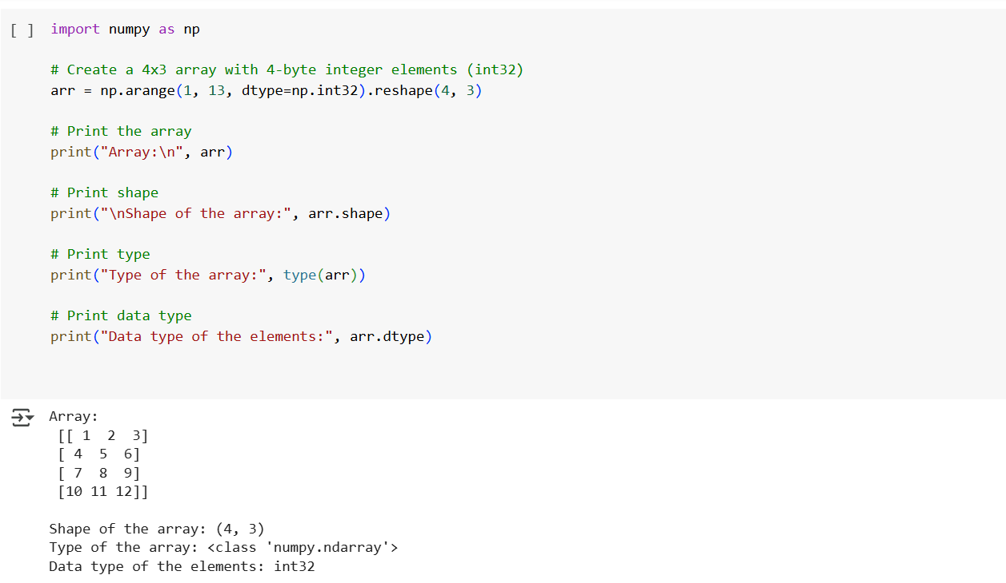

c. Write a program to compute the eigenvalues and right eigenvectors of a given square array given below: [[ 3 -2] [ 1 0]]

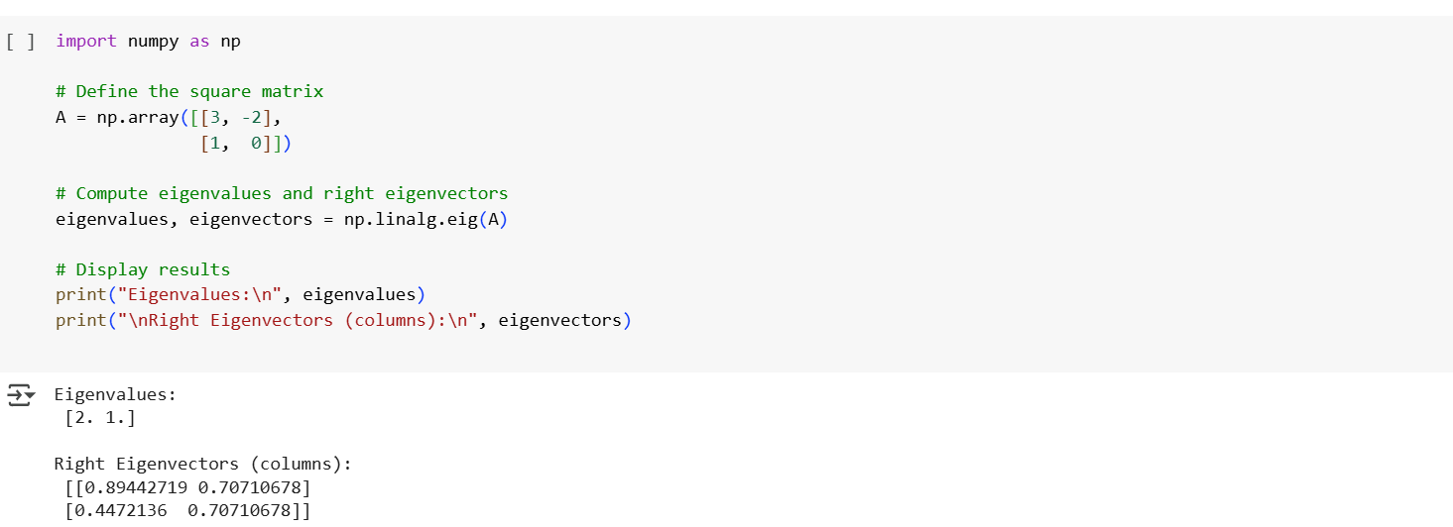

d. Compute the sum of the diagonal element of a given array. [[0 1 2] [3 4 5]]

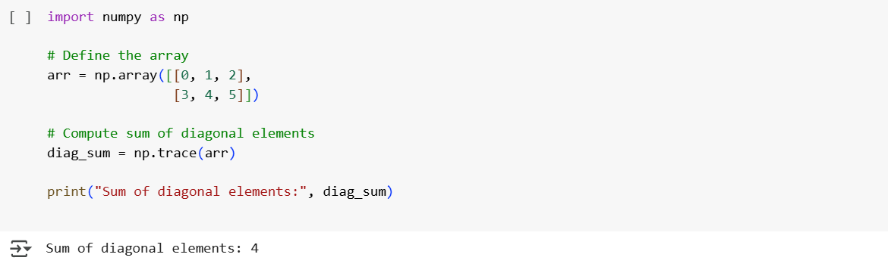

e. Write a NumPy program to create a new shape to an array without changing its data. Reshape 3x2: [[1 2] [3 4] [5 6]] Reshape 2x3: [[1 2 3] [4 5 6]]

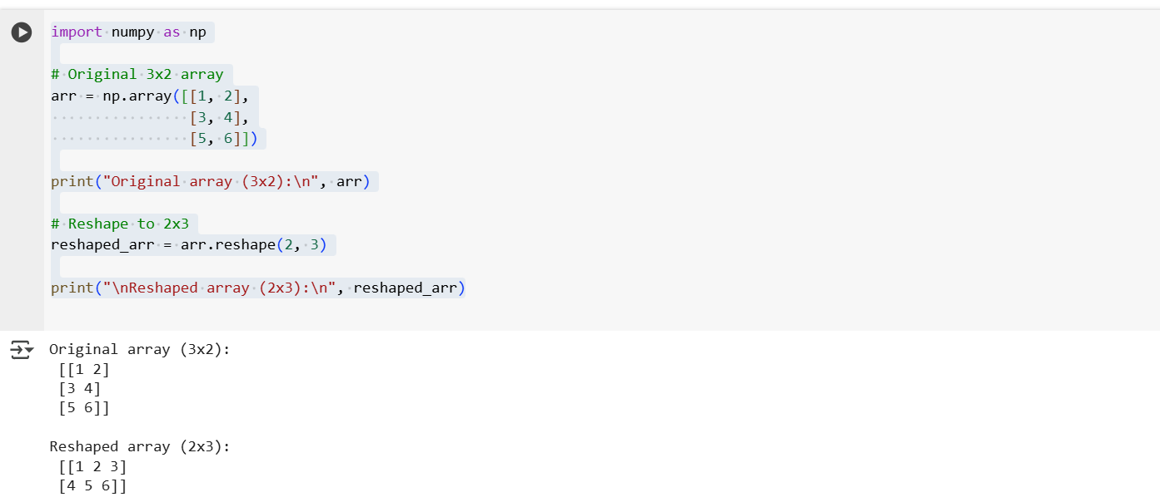

Video Link : <https://www.loom.com/share/7d7412b1d0f84c989682073c28924ea2?sid=c9b0f705-1b37-4acb-bb41-82687112559e>